Posted: 2014 Aug 08 - 06:51
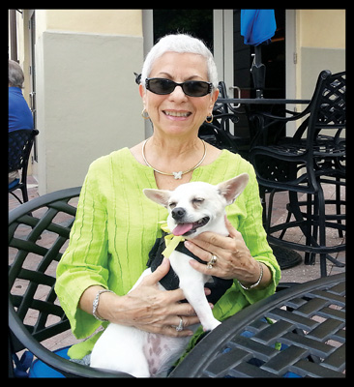

By Donald Rodrigue
For Hometown News

MARTIN COUNTY -- A Martin County resident has received a lifetime achievement award for being a pioneer in the controversial childfree movement begun in the 1970s.
The members of the International Committee for celebrating Aug. 1 as Childfree Day annually honor an exemplary man and woman for their contributions to the childfree community.
This year the organization honored 71-year-old Marcia Drut-Davis of Stuart with its inaugural Lifetime Contributor Award for her tireless efforts promoting the childfree lifestyle. Laura Carroll, committee member and author of "The Baby Matrix," says Ms. Drut-Davis deserved more than just an annual award.
"We couldn't say she's been exemplary for this past year when it's been most of her life," Ms. Carroll said.
A native New Yorker of Jewish descent raised as a humanist, Ms. Drut-Davis gained notoriety in 1974 when she and her former husband decided to equivocally tell his parents that they would not be producing any grandchildren for them. The conversation was filmed to air on a segment of CBS' "60 Minutes" hosted by the late Mike Wallace. What she didn't expect was the backlash from the public over their decision to remain childless.
"I had no idea I would be so maligned by people whose perception of me were not the reality of me," she said.
She subsequently began receiving death threats and lost her position as a permanent substitute teacher on Long Island. Ms. Drut-Davis attributes part of the negative reaction to Wallace's decision to air the conversation with her in-laws on Mother's Day.
"He never met me himself, but the last statement he made before airing the segment was 'pardon our perverseness for airing this on Mother's Day,'" Ms. Drut-Davis said.
In fact, her own parents supported the couple in their decision.
"They accepted my decision," she said "They always made me feel that I had the right to choose the life that made me happy and were shocked at what happened to me," she added.
A certified teacher, Ms. Drut-Davis became disillusioned with the profession after the incident and opened her own direct mail marketing company. Although she was successful, a friend at the time saw her passion for education and prodded her into returning to the field. She earned her master's degree in TSOL at age 50 and once again began teaching in Long Island schools. The East Meadow School District of Long Island nominated her for Walt Disney's National Teacher Award in 1998, selecting her out of more than 600 teachers.
"I was a very passionate and adoring teacher," she said. "I am still connected with several of my former students and their own families now. I was able to have that connection because I had more time to devote to my teaching without having my own family."
Ms. Drut-Davis faced further opposition of protestors when asked by health education teachers on Long Island to address high school students in the face of rising teenage pregnancy rates.
"They asked me to speak on making the choice of having children later on or not at all," she said. "The very, very religious people were offended by this. They didn't want me to teach their kids anything about not having kids."
A pro-choice advocate, Ms. Drut-Davis said she formulated her own decision to remain childfree after reading "The Baby Trap" written by Ellen Peck in 1971. She admits a childfree lifestyle choice is more difficult for couples or women with strong religious convictions and views on abortion.
Their only option might be to give up their children for adoption, she added.
Ms. Drut-Davis and her current husband of 22 years moved to the Treasure Coast 14 years ago. Last November she published her first book, "Confessions of a Childfree Woman". She says women who can't have children need to understand the difference between being childless and childfree and could choose to focus their energy instead on organizations devoted to unwanted or neglected children.
"In my own opinion, the word pronatalism dominates so many people into thinking if they can't have children, they are barren or the sad couple that can't have kids," she said.
"There is a choice," Ms. Drut-Davis said. "You can change your life to become childfree and dedicate your life to the many children who need you."

